Junior Calculation Strategies

Year 3
Number – addition and subtraction |  | Number – multiplication and division
add numbers mentally, including:  - a three-digit number and ones  - a three-digit number and tens  - a three-digit number and hundreds  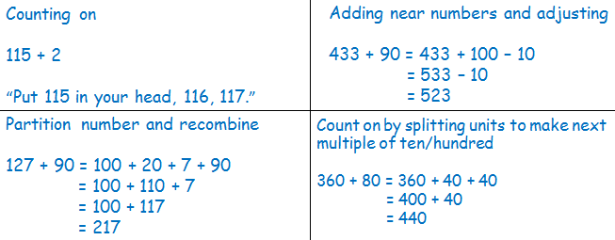  - two two-digit numbers (including answer crossing 100)  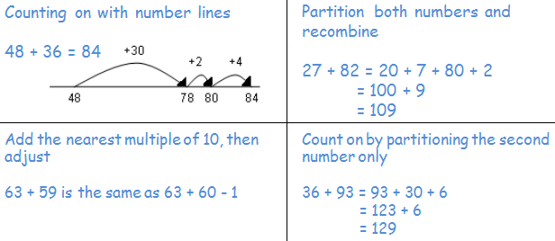 | subtract numbers mentally, including:  - a three-digit number and ones  - a three-digit number and tens  - a three-digit number and hundreds  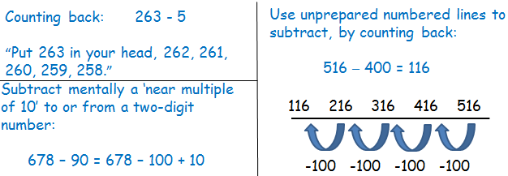  - two two-digit numbers (including answer crossing 100)  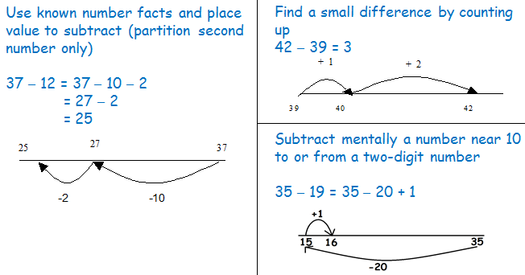 | recall and use multiplication facts for the 3, 4 and 8 multiplication tables  Play games, chant, test etc to increase speed of recalling facts.  Make models and images to display facts.  Investigate patterns within tables. | recall and use division facts for the 3, 4 and 8 multiplication tables  Play games, chant, test etc to increase speed of recalling facts.  Make models and images to display facts.  Investigate patterns within tables.
understand and use mental methods using commutativity and associativity (for example, 4 × 12 × 5 = 4 × 5 × 12 = 20 × 12 = 240)

Use a variety of resources (including a calculator) to investigate order of multiplication.
Make models and images to display facts.

understand and use mental methods using multiplication a facts (e.g. using 3 × 2 = 6, 6 ÷ 3 = 2 and 2 = 6 ÷ 3) to derive related facts (e.g. 30 × 2 = 60, 60 ÷ 3 = 20 and 20 = 60 ÷ 3)

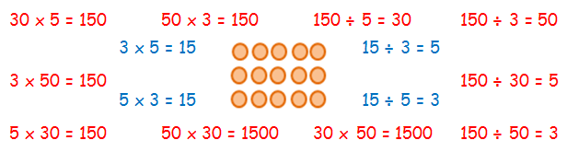
add numbers with up to three digits, using formal written methods of columnar addition (See Appendix 1)  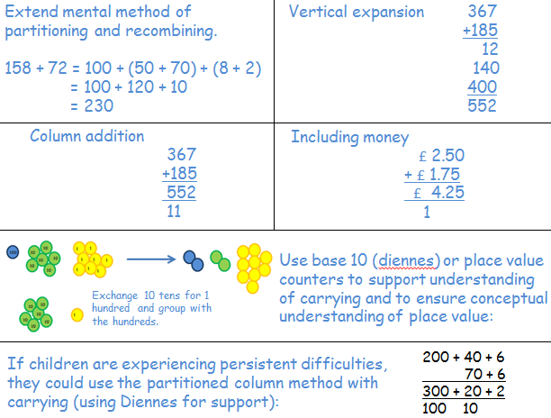 | subtract numbers with up to three digits, using formal written methods of columnar subtraction (See Appendix 1)  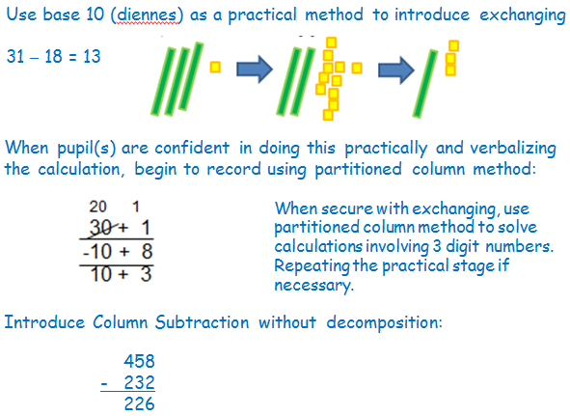 | develop reliable written methods for multiplication, starting with calculations of two-digit numbers by one-digit numbers and progressing to the formal written methods of short multiplication  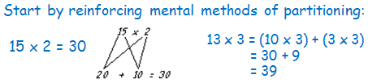  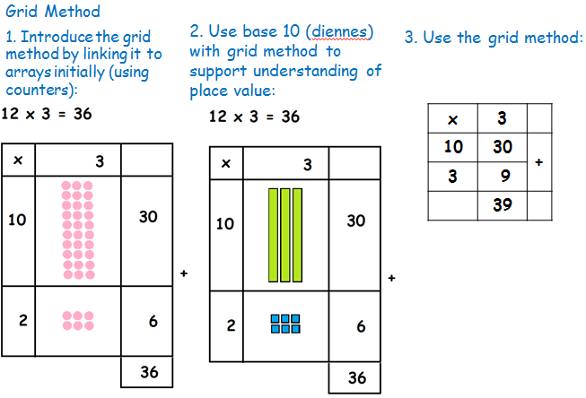 | develop reliable written methods for division, starting with calculations of two-digit numbers by one-digit numbers and progressing to the formal written methods of short division  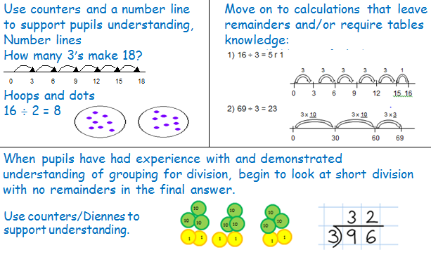
solve problems, including missing number problems, using number facts, place value, and more complex addition  Missing numbers should be placed in all possible places:  3 + 4 = = 4 + 3  3 + = 7 7 = + 4  4 + = 7 7 = 3 +  + ∇ = 7 7 = + ∇  Use all the models and images mentioned above. Discuss which is most effective and why.  Singapore Bar Method  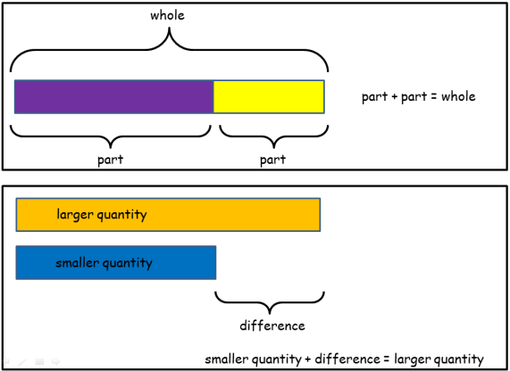 | solve problems, including missing number problems, using number facts, place value, and more complex subtraction  Missing numbers should be placed in all possible places:  16 - 9 = = 16 - 9  16 - = 7 7 = - 9  - 9 = 7 7 = 16 -  - ∇ = 7 7 = - ∇  Use all the models and images mentioned above. Discuss which is most effective and why.  Singapore Bar Method  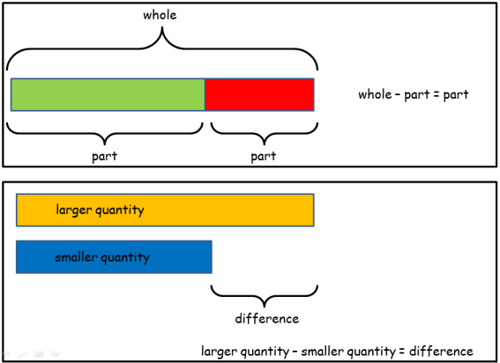 | solve problems, including missing number problems, involving multiplication, including positive integer scaling problems and correspondence problems in which n objects are connected to m objects  solve simple problems in contexts, deciding which of the four operations to use and why  Missing numbers placed in all possible places.  7 x 2 = = 2 x 7  7 x = 14 14 = x 7  x 2 = 14 14 = 2 x  x ∇ = 14 14 = x ∇  Extend to  2 x 6 = 3 x  and using three numbers  10 x x = 60 12 = 2 x x 2  Use all the models and images mentioned above. Discuss which is most effective and why.  Singapore Bar Method  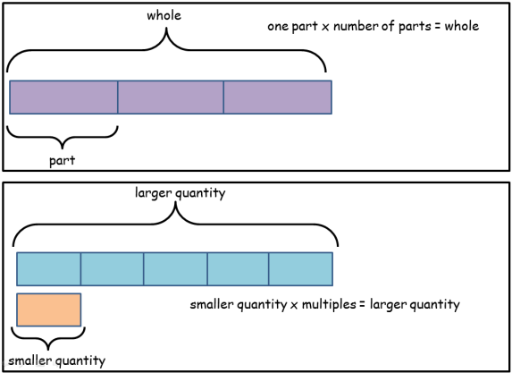 | solve problems, including missing number problems, involving division, including positive integer scaling problems and correspondence problems in which n objects are connected to m objects  solve simple problems in contexts, deciding which of the four operations to use and why  Missing numbers placed in all possible places.  6 ÷ 2 = = 6 ÷ 2  6 ÷ = 3 3 = 6 ÷  ÷ 2 = 3 3 = ÷ 2  ÷ ∇ = 3 3 = ÷ ∇  Extend to  12 ÷ 6 = 8 ÷  and using three numbers  10 ÷ 5 ÷ = 1 3 = 12 ÷ ÷ 2  Use all the models and images mentioned above. Discuss which is most effective and why.  Singapore Bar Method  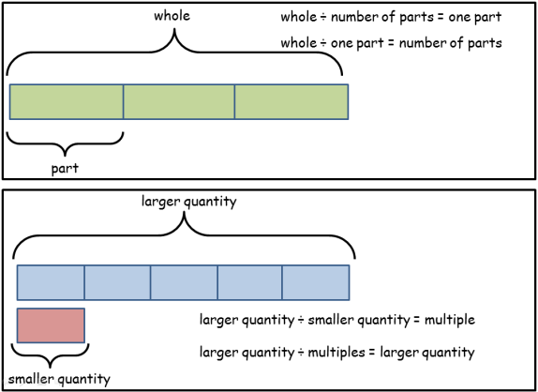
estimate the answer to a calculation and use inverse operations to check answers  Estimate answers before solving any calculation.  Once inverse operation has been learnt use as a method for checking. | estimate the answer to a calculation and use inverse operations to check answers  Estimate answers before solving any calculation.  Once inverse operation has been learnt use as a method for checking. | write and calculate mathematical statements for multiplication using the multiplication tables that they know, including for two-digit numbers times one-digit numbers, using mental and progressing to formal written methods  See models and images above. | write and calculate mathematical statements for division using the multiplication tables that they know, including for two-digit numbers times one-digit numbers, using mental and progressing to formal written methods  See models and images above.
use a variety of language to describe addition  +, add, addition, more, plus, make, sum, total, altogether, score, double, near double, one more, two more... ten more... one hundred more, how many more to make…? how many more is… than…? how much more is…?  = equals, sign, is the same as  tens boundary, hundreds boundary | use a variety of language to describe subtraction  - subtract, subtraction, take (away), minus, leave, how many are left/left over? one less, two less… ten less… one hundred less, how many fewer is… than…? how much less is…? difference between, half, halve  = equals, sign, is the same as | use a variety of language to describe multiplication  count, count (up) to, count on (from, to), count back (from, to), count in ones, wos, threes, fours, fives… count in tens, hundreds, lots of, groups of, , times, multiply, multiplication, multiplied by, multiple of, product, once, twice, three times… ten times…times as (big, long, wide… and so on), repeated addition, array, row, column  = equals, sign, is the same as | use a variety of language to describe division  Array, row, column, halve, share, share equally, one each, two each, three each… group in pairs, threes… tens, equal groups of, ÷, divide, division, divided by, divided into, left, left over, remainder  = equals, sign, is the same as

Year 4
Number – addition and subtraction |  | Number – multiplication and division
add numbers mentally, including:  - a four-digit number and ones  - a four-digit number and tens  - a four-digit number and hundreds  - a four-digit number and thousands  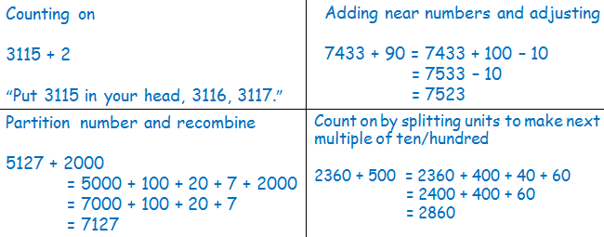  - three and two-digit numbers  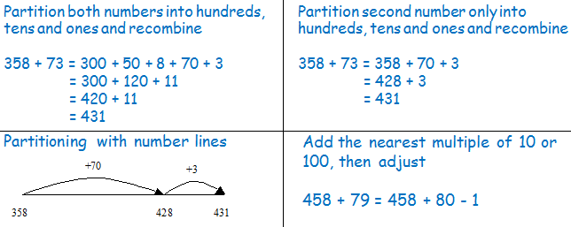 | subtract numbers mentally, including:  - a four-digit number and ones  - a four-digit number and tens  - a four-digit number and hundreds  - a four-digit number and thousands  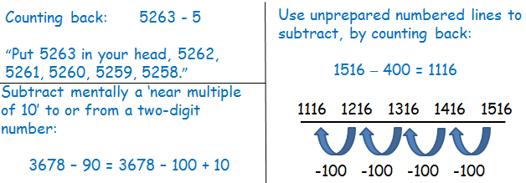  - three and two-digit numbers  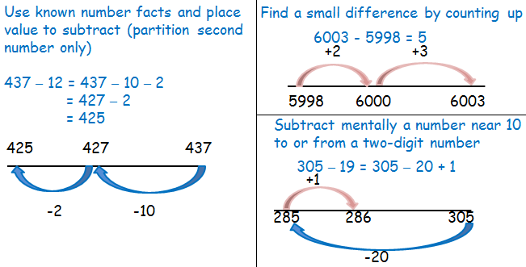 | recall multiplication facts for multiplication tables up to 12 × 12  Play games, chant, test etc to increase speed of recalling facts.  Make models and images to display facts.  Investigate patterns within tables. | recall division facts for multiplication tables up to 12 × 12  Play games, chant, test etc to increase speed of recalling facts.  Make models and images to display facts.  Investigate patterns within tables.
 |  | use place value, known and derived facts to multiply mentally, including: multiplying by 0 and 1; multiplying together three numbers  practise and extend mental methods to three-digit numbers to derive facts, (for example 600 ÷ 3 = 200 can be derived from 2 x 3 = 6)  Use knowledge of multiplication facts and place value to derive related facts.  Partition  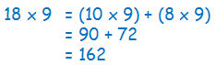 | use place value, known and derived facts to divide mentally, including: dividing by 1 practise and extend mental methods to three-digit numbers to derive facts, (for example 600 ÷ 3 = 200 can be derived from 2 x 3 = 6)  Use knowledge of multiplication facts and place value to derive related facts.  Partitioning/Chunking  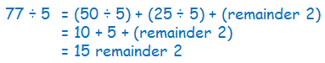.
 |  | recognise and use commutativity in mental calculations  write statements about the equality of expressions (for example, use the distributive law 39 × 7 = 30 × 7 + 9 × 7 and associative law  (2 × 3) × 4 = 2 × (3 × 4))  Use a variety of resources (including a calculator) to investigate order of multiplication. Make models and images to display facts. | recognise and use factor pairs in mental calculations  Use a variety of resources (including a calculator) to investigate factor pairs. Make models and images to display facts.
add numbers with up to 4 digits using the formal written methods of columnar addition and subtraction where appropriate (see Appendix 1)  Column addition  2358  + 373  2731  1 1  To ensure conceptual understanding, it is essential that place value is reinforced by frequently.  Discussing the actual value of each digit, e.g. the 5 digit represents 5 hundreds.  Use base 10 (Diennes) or place value counters to support understanding of carrying and to ensure conceptual understanding of place value (see year 2 and 3 for how to use these manipulatives).  Including decimals  72.8  + 54.6  127.4  1  To ensure conceptual understanding, it is essential that place value is reinforced by frequently discussing the actual value of each digit, e.g. the 2 digit represents 2 tens.  Use money to support understanding. | subtract numbers with up to 4 digits using the formal written methods of columnar addition and subtraction where appropriate (see Appendix 1)  Revision of partitioned column method from Year 3. Moving on to numbers with 4 digits: (use Diennes to support when required.)  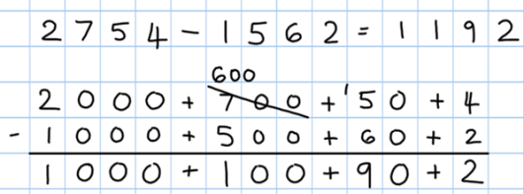  Column Subtraction without decomposition  458  - 232  226  Column Subtraction with decomposition  Once pupils are confident in exchanging and have a clear understanding of place value, move towards the formal compact column method: (use Diennes to support when required.)  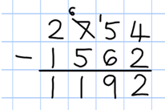 | multiply two-digit and three-digit numbers by a one-digit number using formal written layout (see Appendix 1)  Grid method  231 x 7 is approximately 200 x 10 = 2000  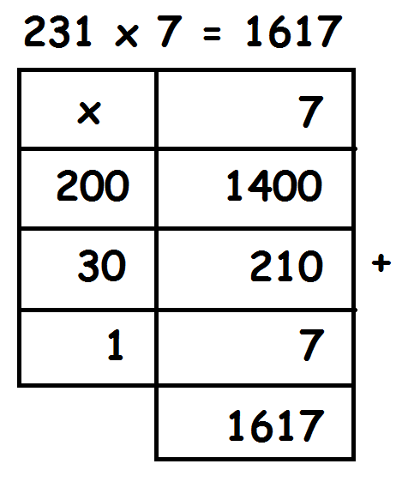  move onto formal method of short multiplication when proficient  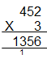 | divide numbers up to 3 digit by a one-digit number using the formal written method of short division and begin to interpret remainders.  Short division with no remainders in the final answer, use place value counters/Diennes where support is required.  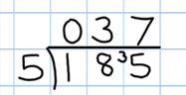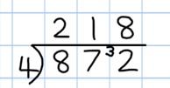  Remainders  Begin to interpret remainders by looking at word problems to give context and small numbers to start with.  Cars carry 5 people. !2 people are going on a trip. How many cars will they need?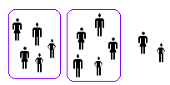  12 ÷ 5 = 2 r 2 So they would need 3 cars.  5 buttons are packed in a bag. How many full bags would there be if there were 12 buttons?  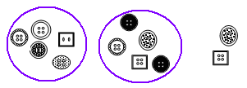  12 ÷ 5 = 2 r 2. So there are 2 full bags.
solve addition two-step problems in contexts, deciding which operations and methods to use and why  Use all the models and images mentioned above. Discuss which is most effective and why.  Singapore Bar Method  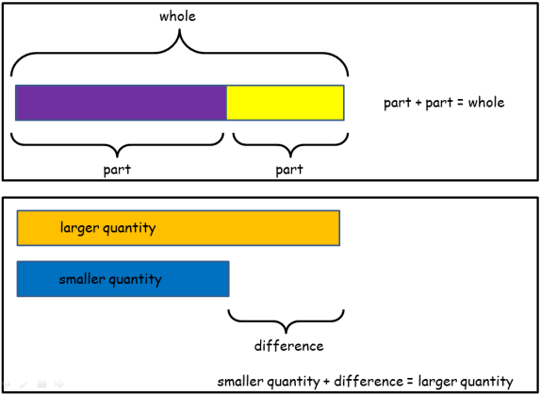 | solve subtraction two-step problems in contexts, deciding which operations and methods to use and why  Use all the models and images mentioned above. Discuss which is most effective and why.  Singapore Bar Method  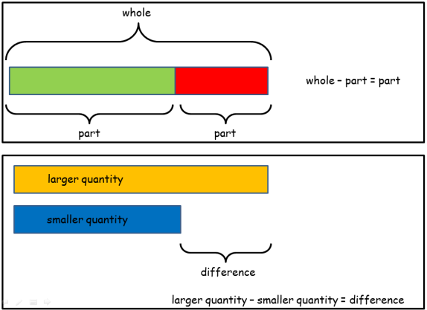 | solve problems involving multiplying and adding, including using the distributive law to multiply two digit numbers by one digit, integer scaling problems and harder correspondence problems such as n objects are connected to m objects  solve two-step problems in contexts, choosing the appropriate operation, working with increasingly harder numbers  Use all the models and images mentioned above. Discuss which is most effective and why.  Singapore Bar Method  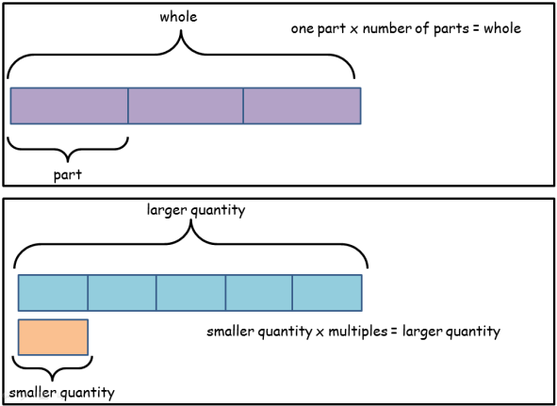 | solve two-step problems in contexts, choosing the appropriate operation, working with increasingly harder numbers  Use all the models and images mentioned above. Discuss which is most effective and why.  Singapore Bar Method  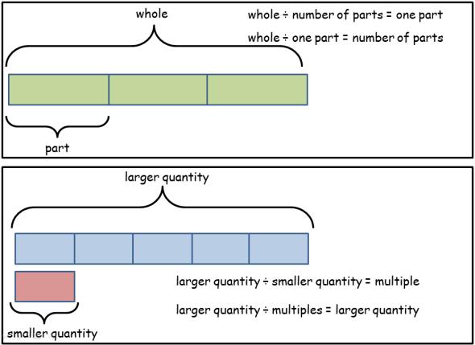
estimate and use inverse operations to check answers to a calculation  Estimate answers before solving any calculation.  Once inverse operation has been learnt use as a method for checking. | estimate and use inverse operations to check answers to a calculation  Estimate answers before solving any calculation.  Once inverse operation has been learnt use as a method for checking. | estimate and use inverse operations to check answers to a calculation  Estimate answers before solving any calculation.  Once inverse operation has been learnt use as a method for checking. | estimate and use inverse operations to check answers to a calculation  Estimate answers before solving any calculation.  Once inverse operation has been learnt use as a method for checking.
use a variety of language to describe addition  + add, addition, more, plus, increase, sum, total, altogether, score, double, near double, how many more to make…? tens boundary, hundreds boundary, inverse  = equals, sign, is the same as | use a variety of language to describe subtraction  - subtract, subtraction, take (away), minus, decrease, leave, how many are left/left over? difference between, half, halve, how many more/fewer is… than…? how much more/less is…? tens boundary, hundreds boundary, inverse  = equals, sign, is the same as | use a variety of language to describe multiplication  times, multiply, multiplication, multiplied by, multiple of, product  once, twice, three times… ten times… times as (big, long, wide… and so on)  repeated addition array, row, column, double, inverse  = equals, sign, is the same as | use a variety of language to describe division  Array, row, column, halve, share, share equally, one each, two each, three each…  group in pairs, threes… tens. equal groups of, divide, division, divided by, divided into, remainder, factor, quotient, divisible by, inverse  = equals, sign, is the same as

Year 5
Number – addition and subtraction |  | Number – multiplication and division
add numbers mentally with increasingly large numbers ( e.g. 12 462 – 2300 = 10 162)  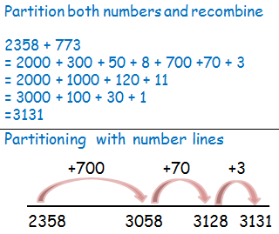  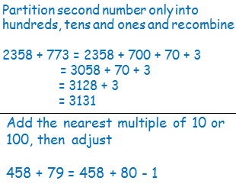 | subtract numbers mentally with increasingly large numbers ( e.g. 12 462 – 2300 = 10 162)  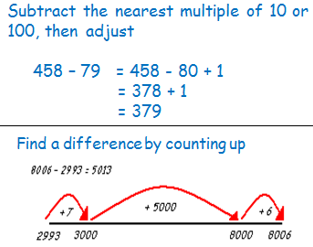  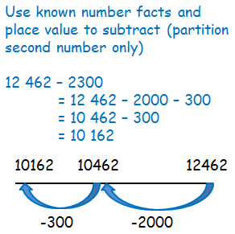 | multiply numbers mentally drawing upon known facts  Partition  47 x 6 = (40 x 6) + (7 x 6)  = ( 240 ) + ( 42 )  = 282  Double and halve  25 x 16 = 50 x 8 = 100 x 4 = 200 x 2 = 400 | divide numbers mentally drawing upon known facts  Partitioning  72 ÷ 3 = (60 ÷ 3 ) = (12 ÷ 3)  = 20 + 4  = 24
 |  | multiply whole numbers and those involving decimals by 10, 100 and 1000  Place Value  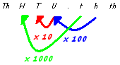 | divide whole numbers and those involving decimals by 10, 100 and 1000  Place Value  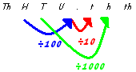
 |  | identify multiples, (and use them to construct equivalence statements, e.g. 4 x 35 = 2 x 2 x 35; 3 x 270 = 3 x 3 x 9 x 10 = 9² x 10)  Use a variety of resources (including a calculator) to investigate multiples. Make models and images to display facts. | identify factors, including finding all factor pairs of a number, and common factors of two numbers (and use them to construct equivalence statements, e.g. 4 x 35 = 2 x 2 x 35; 3 x 270 = 3 x 3 x 9 x 10 = 9² x 10)  Use a variety of resources (including a calculator) to investigate factors. Make models and images to display facts.
 |  | recall prime numbers up to 19  establish whether a number up to 100 is prime  Play games, chant, test etc to increase speed of recalling facts.  Make models and images to display facts.  Investigate patterns within primes. | recall prime numbers up to 19  establish whether a number up to 100 is prime  Play games, chant, test etc to increase speed of recalling facts.  Make models and images to display facts.  Investigate patterns within primes.
recognise and use square numbers and cube numbers, and the notation for squared (²) and cubed (³)

Use a variety of resources (including a calculator) to investigate square and cubed numbers. Make models and images to display facts.
Investigate the patterns within squared and cubed numbers.

add numbers with more than 4 digits, including using formal written methods (columnar addition and subtraction – see Appendix 1)  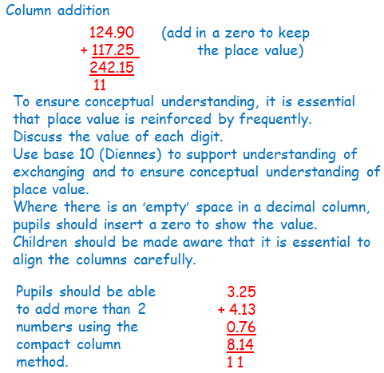 | subtract numbers with more than 4 digits, including using formal written methods (columnar addition and subtraction – see Appendix 1)  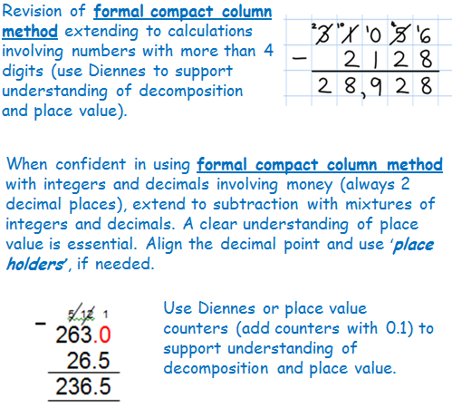 | multiply numbers up to 4 digits by a one- or two-digit number using a formal written method, including long multiplication for two-digit numbers  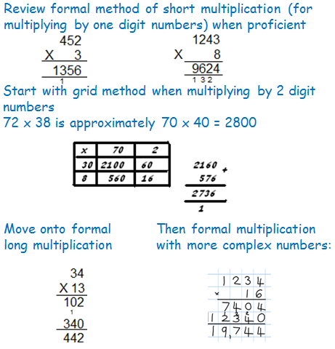 | divide numbers up to 4 digits by a one-digit number using the formal written method of short division and interpret remainders appropriately for the context (as fractions, as decimals or by rounding (for example, 98 ÷ 4 = 98/4 = 24 r 2 = 24 ½ = 24.5 ≈ 25))  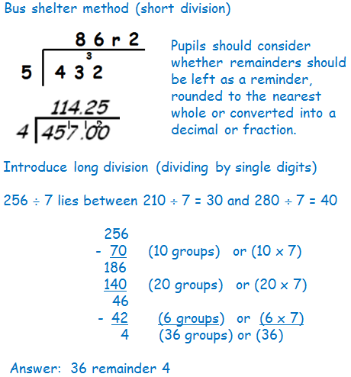
solve addition multi-step problems in contexts, deciding which operations and methods to use and why  Use all the models and images mentioned above. Discuss which is most effective and why.  Singapore Bar Method | solve subtraction multi-step problems in contexts, deciding which operations and methods to use and why  Use all the models and images mentioned above. Discuss which is most effective and why.  Singapore Bar Method | Solve problems that use multiplication and division as inverses, for example, by multiplying and dividing by powers of 10 in scale drawings or by multiplying and dividing by powers of a 1000 in converting between units such as kilometres and metres  Use all the models and images mentioned above. Discuss which is most effective and why.  Singapore Bar Method | Solve problems that use multiplication and division as inverses, for example, by multiplying and dividing by powers of 10 in scale drawings or by multiplying and dividing by powers of a 1000 in converting between units such as kilometres and metres  Use all the models and images mentioned above. Discuss which is most effective and why.  Singapore Bar Method
 |  | use and explain the equals sign to indicate equivalence, including missing number problems (e.g, 13+24 = 12+25; 33 = 5 x [] )  express distributivity, for example as a(b + c) = ab + ac  Use all of the models and images above to investigate a range of statements, ensuring the equals sign is in different positions. Allow time for discussion and reasoning. Display solutions and reasoning. Also use errors or misconceptions as a starting point. | use and explain the equals sign to indicate equivalence, including missing number problems (e.g, 13+24 = 12+25; 33 = 5 x [] )  Use all of the models and images above to investigate a range of statements, ensuring the equals sign is in different positions. Allow time for discussion and reasoning. Display solutions and reasoning. Also use errors or misconceptions as a starting point.
use rounding to check answers to calculations and determine, in the context of a problem, levels of accuracy  Estimate answers before solving any calculation.  Check against estimate after calculating (and use inverse check). | use rounding to check answers to calculations and determine, in the context of a problem, levels of accuracy  Estimate answers before solving any calculation.  Check against estimate after calculating (and use inverse check). | use rounding to check answers to calculations and determine, in the context of a problem, levels of accuracy  Estimate answers before solving any calculation.  Check against estimate after calculating (and use inverse check). | use rounding to check answers to calculations and determine, in the context of a problem, levels of accuracy  Estimate answers before solving any calculation.  Check against estimate after calculating (and use inverse check).
use a variety of language to describe addition  + add, addition, more, plus, increase, sum, total, altogether, score, double, near double, how many more to make…? tens boundary, hundreds boundary, units boundary, tenths boundary, inverse  = equals, sign, is the same as | use a variety of language to describe subtraction  - subtract, subtraction, take (away), minus, decrease, leave, how many are left/left over? difference between, half, halve, how many more/fewer is… than…? how much more/less is…? tens boundary, hundreds boundary, units boundary, tenths boundary, inverse  = equals, sign, is the same as | use a variety of language to describe multiplication  know and use the vocabulary of prime numbers, prime factors and composite (nonprime) numbers  lots of, groups of, times, multiply, multiplication, multiplied by, multiple of, product, once, twice, three times… ten times… times as (big, long, wide… and so on), repeated addition, array, row, column, double,, inverse, prime,  equals, sign, is the same as | use a variety of language to describe division  Array, row, column, halve, share, share equally one each, two each, three each…  group in pairs, threes… tens, equal groups of, divide, division, divided by, divided into, remainder, factor, quotient, divisible by, inverse. Prime, factors  equals, sign, is the same as

Year 6
Number – addition and subtraction |  | Number – multiplication and division
perform mental calculations, including with mixed operations and large numbers (and decimals)  Partition both numbers into hundreds, tens, ones and decimal fractions and recombine  35.8 + 7.3 = 30 + 5 + 0.8 + 7 + 0.3  = 30 + 12 + 1.1  = 42 + 1.1  = 43.1  Partition second number only into hundreds, tens, ones and decimal fractions and recombine  35.8 + 7.3 = 35.8 + 7 + 0.3  = 42.8 + 0.3  = 43.1  Add the nearest whole number then adjust  52 + 11.9 = 52 + 12 – 0.1  = 64 – 0.1  = 63.9 | perform mental calculations, including with mixed operations and large numbers(and decimals)  Use known number facts and place value to subtract  6.1 – 2.4 = 3.7  Subtract the nearest whole number then adjust  52 - 11.9 = 52 - 12 + 0.1  = 40 + 0.1  = 40.1 | perform mental calculations, including with mixed operations and large numbers(and decimals)  Partitioning  4.7 x 6 = (4 x 6) + (0.7 x 6)  = ( 24 ) + ( 4.2 )  = 28.2  Double and halve  4.25 x 32 = 8.5 x 16  = 17 x 8  = 34 x 4  = 68 x 2  = 136 | perform mental calculations, including with mixed operations and large numbers(and decimals)  Partitioning  7.2 ÷ 3 = (6 ÷ 3 ) = (1.2 ÷ 3)  = 2 + 0.4  = 2.4
 |  | identify common factors, common multiples and prime numbers  Use a variety of resources (including a calculator) to investigate common factors, common multiples and prime numbers. Make models and images to display facts. Investigate the patterns within the numbers. | identify common factors, common multiples and prime numbers  Use a variety of resources (including a calculator) to investigate common factors, common multiples and prime numbers. Make models and images to display facts. Investigate the patterns within the numbers.
practise addition for larger numbers, using the formal written methods of columnar addition (see Appendix 1)  Extend the use of compact column method to adding several numbers with mixed decimals.  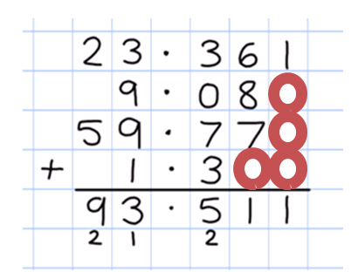  Children should be reminded of the importance of aligning the columns accurately.  Where there is an ‘empty’ space in a decimal column, pupils could insert a zero to show the value. | practise subtraction for larger numbers, using the formal written methods of columnar subtraction (see Appendix 1)  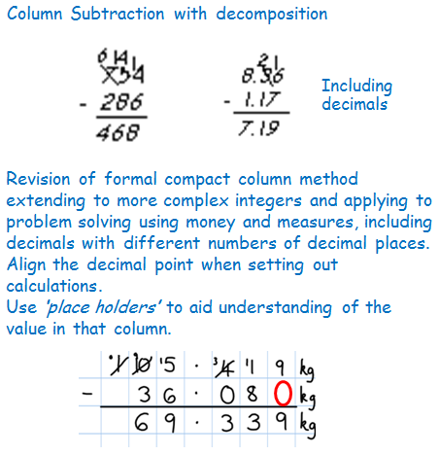 | multiply multi-digit numbers up to 4 digits by a two-digit whole number using the formal written method of short and long multiplication (Appendix 1)  Short multiplication and Long multiplication as in Year 5, but apply to numbers with decimals.  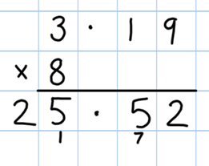  Pupils may need reminding that single digits belong in the ones (units) column.  A sound understanding of place value and the formal method itself are required before progressing to decimal multiplication. | divide numbers up to 4 digits by a two-digit whole number using the formal written method of short and long division, and interpret remainders as whole number remainders, fractions, or by rounding, as appropriate for the context (Appendix 1)  Short division  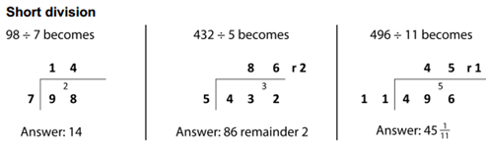  Long division (for dividing by 2 digits)  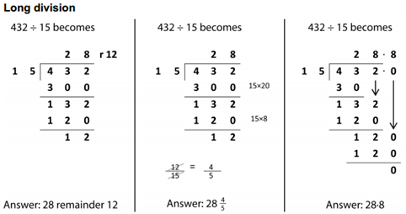  Remainders  Quotients expressed as fractions or decimal fractions  61 ÷ 4 = 15 ¼ or 15.25
solve addition multi-step problems in contexts, deciding which operations and methods to use and why  Use all the models and images mentioned above. Discuss which is most effective and why.  Singapore Bar Method | solve subtraction multi-step problems in contexts, deciding which operations and methods to use and why  Use all the models and images mentioned above. Discuss which is most effective and why.  Singapore Bar Method | solve problems involving multiplication  Use all the models and images mentioned above. Discuss which is most effective and why.  Singapore Bar Method | solve problems involving division  Use all the models and images mentioned above. Discuss which is most effective and why.  Singapore Bar Method
round answers to a specified degree of accuracy, e.g. to the nearest 10, 20, 50 etc., but not to a specified number of significant figures  Use knowledge of rounding (see fraction Policy) to create estimates. | round answers to a specified degree of accuracy, e.g. to the nearest 10, 20, 50 etc., but not to a specified number of significant figures  Use knowledge of rounding (see fraction Policy) to create estimates. | round answers to a specified degree of accuracy, for example, to the nearest 10, 20, 50 etc., (not to specified number of significant figures)  Use knowledge of rounding (see fraction Policy) to create estimates. | round answers to a specified degree of accuracy, e.g. to the nearest 10, 20, 50 etc., but not to a specified number of significant figures  Use knowledge of rounding (see fraction Policy) to create estimates.
use their knowledge of the order of operations to carry out calculations involving the four operations  explore the order of operations using brackets; for example, 2 + 1 x 3 = 5 and (2 + 1) x 3 = 9  Review and investigate the effect of carrying out operations in different orders. Explore the effect.  Introduce and use BODMAS to solve calculations. | use their knowledge of the order of operations to carry out calculations involving the four operations  explore the order of operations using brackets; for example, 2 + 1 x 3 = 5 and (2 + 1) x 3 = 9  Review and investigate the effect of carrying out operations in different orders. Explore the effect.  Introduce and use BODMAS to solve calculations. | use their knowledge of the order of operations to carry out calculations involving the four operations  explore the order of operations using brackets; for example, 2 + 1 x 3 = 5 and (2 + 1) x 3 = 9  Review and investigate the effect of carrying out operations in different orders. Explore the effect.  Introduce and use BODMAS to solve calculations. | use their knowledge of the order of operations to carry out calculations involving the four operations  explore the order of operations using brackets; for example, 2 + 1 x 3 = 5 and (2 + 1) x 3 = 9  Review and investigate the effect of carrying out operations in different orders. Explore the effect.  Introduce and use BODMAS to solve calculations.
use estimation to check answers to calculations and determine, in the context of a problem, an appropriate degree of accuracy  Estimate answers before solving any calculation.  Check against estimate after calculating (and use inverse check). | use estimation to check answers to calculations and determine, in the context of a problem, an appropriate degree of accuracy  Estimate answers before solving any calculation.  Check against estimate after calculating (and use inverse check). | use estimation to check answers to calculations and determine, in the context of a problem, an appropriate degree of accuracy  Estimate answers before solving any calculation.  Check against estimate after calculating (and use inverse check). | use estimation to check answers to calculations and determine, in the context of a problem, an appropriate degree of accuracy  Estimate answers before solving any calculation.  Check against estimate after calculating (and use inverse check).
use a variety of language to describe subtraction  + add, addition, more, plus, increase, sum, total, altogether, score, double, near double, how many more to make…? tens boundary, hundreds boundary, units boundary, tenths boundary, inverse  = equals, sign, is the same as | use a variety of language to describe subtraction  - subtract, subtraction, take (away), minus, decrease, leave, how many are left/left over? difference between, half, halve, how many more/fewer is… than…? how much more/less is…? tens boundary, hundreds boundary, units boundary, tenths boundary,  inverse  = equals, sign, is the same as | use a variety of language to describe subtraction  x lots of, groups of, times, multiply, multiplication, multiplied by, multiple of, product, once, twice, three times… ten times… times as (big, long, wide… and so on), repeated addition, array, row, column  double, inverse  = equals, sign, is the same as | use a variety of language to describe subtraction  Array, row, column, halve, share, share equally one each, two each, three each… group in pairs, threes… tens, equal groups of, divide, division, divided by, divided into, remainder, factor, quotient, divisible by, inverse  = equals, sign, is the same as

