Infants Calculation Strategies
EYFS
Number – addition and subtraction |  | Number – multiplication and division
add two single digit numbers  aggregation  Counters on plates    1, 2, 3, 4, 5, 6.  Bead strings or bead bars can be used to illustrate addition including bridging ten by counting on 2 then 3.  5 + 3 = 8  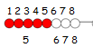 | subtract two single digit numbers  reduction  Counters on plates  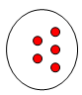  6 take away 1 leaves  1, 2, 3, 4, 5.  Cross out drawn objects to represent what has been taken away:  3 take away 2 is 1  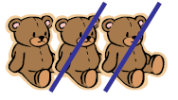  Start with 3 … 2, 1. | solve problems including doubling  Practically double a group of objects to find double of a number by combining then counting the two groups:  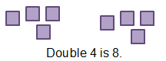  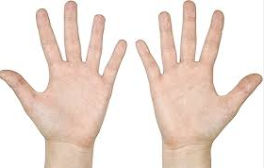  5 and 5  is 10 | solve problems including halving and sharing  Sharing objects  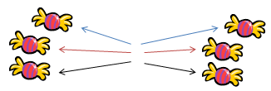  One for you. One for me…  Is it fair? How many do we each have?  15 shared between 5 is 3.  Grouping objects  Put groups of objects on plates.  How many groups of 4 are there in 12 stars?  
Count on to find the answer  augmentation  Practically with objects, fingers etc.  5 + 2 “Put 5 in your head, 6, 7.”  Dice… 4 + 3 = 7  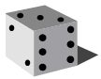  4, 5, 6, 7.  On a prepared number line (start with the bigger number)...  2 + 4 = 6  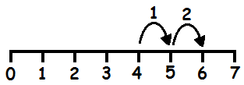 | Count on or back to find the answer  Practically, for example:  Group objects on a table then cover some to visualize the calculation:  2 less than 4 is 2  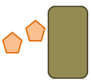  Start with 2… 3, 4.  Coins    I had 10 pennies. I spent 4 pence. How much do I have left? Start with 10… 9, 8, 7, 6.
understand and use vocabulary for addition  add, more, and, make, sum, total, altogether, score, double, one more, two more, ten more… how many more to make… ? how many more is… than…?  is the same as | understand and use vocabulary for subtraction  take (away), leave, how many are left/left over? how many have gone? one less, two less… ten less… how many fewer is… than…? difference between  is the same as | understand and use vocabulary for multiplication  count on (from, to), count back (from, to), count in ones, twos… tens…  is the same as | understand and use vocabulary for division  half, halve, count out, share out, left, left over  is the same as
Year 1
Number – addition and subtraction |  | Number – multiplication and division
represent and use number bonds up to 20  Start with number bonds to 10 then build. Use a wide range of objects (including fingers!) and images to model the bonds, e.g. interlocking cubes.  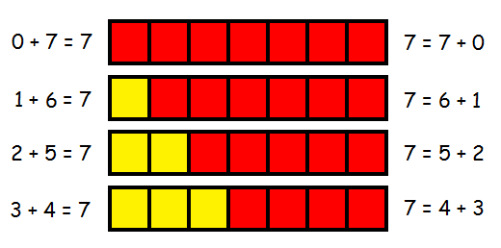 | represent and use number bond facts related subtraction up to 20  Start with number bonds to 10 then build. Use a wide range of objects (including fingers!) and images to model the bonds, e.g. interlocking cubes.  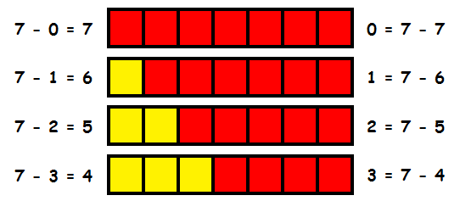 | count in multiples of twos, fives and tens (from number and place value)  Counting using a variety of practical resources  Counting in 2s e.g. counting socks, shoes, animals in the ark…  Counting in 10s e.g. hundred square, towers of cubes…  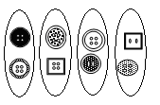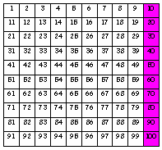  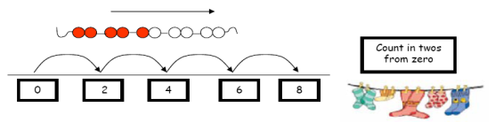  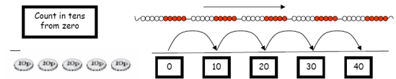  Use rhymes, songs and stories involving counting on and counting back in ones, twos, fives and tens.  Use 2p, 5p and 10p coins. | group and share small quantities  Practical activities involving sharing,  Distributing cards when playing a game, putting objects onto plates, into cups, hoops etc.  Grouping  Sorting objects into 2s / 3s/ 4s etc  How many pairs of socks are there?  There are 12 crocus bulbs. Plant 3 in each pot. How many pots are there?  Jo has 12 Lego wheels. How many cars can she make?  Sharing pictures /objects  12 children get into teams of 4 to play a game. How many teams are there?  Sweets are shared between 2 people. How many do they have each?
add one-digit and two-digit numbers to 20, including zero  Bead strings or bead bars can be used to illustrate addition including bridging ten by counting on 2 then 3.  8 + 5  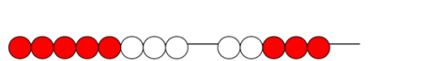  On a prepared number line… 7 + 4 = 11  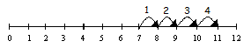  On a hundred square… 3 + 4  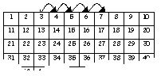 | subtract one-digit and two-digit numbers to 20, including zero  Practically with objects, fingers etc.  5 - 2 “Put 5 in your head, 4, 3.”  Taking away  Number lines (numbered and unnumbered, prepared and child constructed)  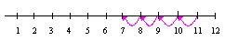  Hundred Square  17 - 3  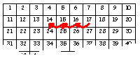  Finding the difference  Number lines (numbered and unnumbered, prepared and child constructed)  Use practical equipment (such as numicon or cuisenaire) to identify the ‘difference’:  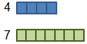  ‘The difference between 7 and 4 is 3’ or ‘Seven is 3 more than four’.
 |  | double numbers and quantities  Practically double a group of objects and/or quantities to find double of a number by combining then counting the two groups.  Progress onto using known facts and counting (in 1s, 2s, 5s and 10s) to double more efficiently.  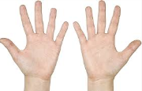  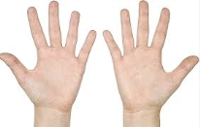  10 and 10  is 20 | half numbers and quantities  Practically halve objects and/or qualities by sharing them out into two piles and then counting the number of objects in each pile, or cutting/folding pictures of objects in half.  Progress onto using known facts and counting (in 1s, 2s, 5s and 10s) to halve more efficiently.  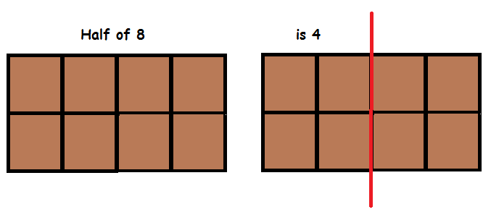

read, write and interpret mathematical statements involving addition (+) and equals (=) signs  It is important to that children have a clear understanding of the concept of equality, before using the ‘=’ sign. Calculations should be on either side of the ‘=’ to that children don’t misunderstand ‘=’ as to mean ‘the answer’.  15 + 2 = 17  15 = 3 + 12 | read, write and interpret mathematical statements involving and subtraction (–) equals (=) signs  It is important to that children have a clear understanding of the concept of equality, before using the ‘=’ sign. Calculations should be on either side of the ‘=’ to that children don’t misunderstand ‘=’ as to mean ‘the answer’.  15 - 2 = 13  15 = 18 - 3 | make connections between arrays and number patterns  Arrays  Looking at columns Looking at rows  2 + 2 + 2 3 + 3  3 groups of 2 2 groups of 3  Arrays and repeated addition  4 x 2 or 4 + 4  2 x 4  or 2 + 2 + 2 + 2 | make connections between arrays and number patterns  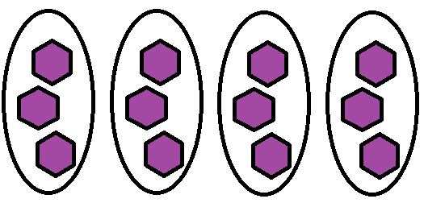  There are 4 groups of 3 in 12.  12 shared between 4 is 3.
solve one-step problems that involve addition and subtraction, using concrete objects and pictorial representations, and missing number problems such as 7 = [] + 4  To support this, when solving calculations, missing numbers should be placed in all possible places:  3 + 4 = = 4 + 3  3 + = 7 7 = + 4  4 + = 7 7 = 3 +  + ∇ = 7 7 = + ∇  Use all the models and images mentioned above. Discuss which is most effective and why.  Singapore Bar Method  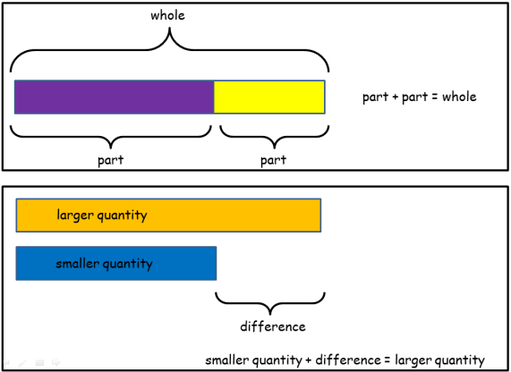 | solve one-step problems that involve addition and subtraction, using concrete objects and pictorial representations, and missing number problems such as 7 = []– 9  To support this, when solving calculations, missing numbers should be placed in all possible places:  16 - 9 = = 16 - 9  16 - = 7 7 = - 9  - 9 = 7 7 = 16 -  - ∇ = 7 7 = - ∇  Use all the models and images mentioned above. Discuss which is most effective and why.  Singapore Bar Method  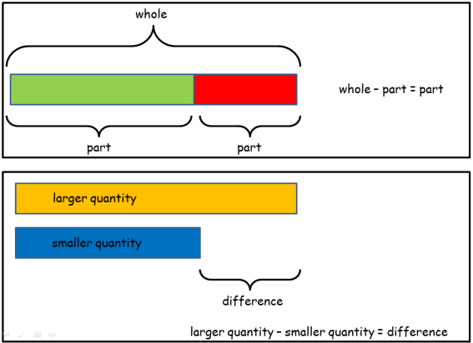 | solve one-step problems involving multiplication, by calculating the answer using concrete objects, pictorial representations and arrays with the support  Use all the models and images mentioned above. Discuss which is most effective and why.  Singapore Bar Method  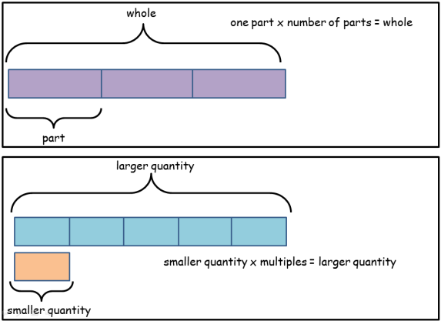 | solve one-step problems involving division, by calculating the answer using concrete objects, pictorial representations and arrays with the support  Use all the models and images mentioned above. Discuss which is most effective and why.  Singapore Bar Method  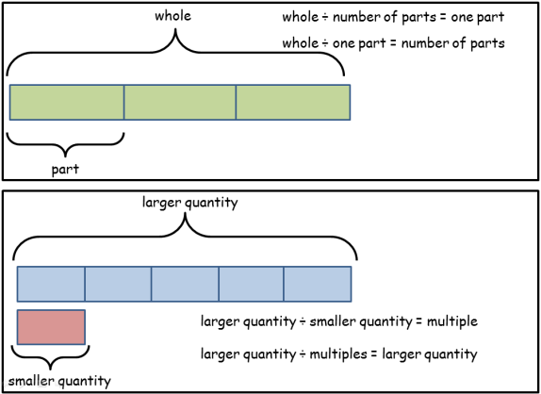
understand and use vocabulary for addition, e.g. put together, add, altogether, total and more than  +, add, more, plus, make, total, altogether, score, double, near double, one more, two more… ten more,  = equals, sign, is the same as  How many more to make…? How many more is… than…? How much more is…? Repetition of facts with different vocabulary:  “What is 2 add 5?” “What is 2 more than 5?”  “What is 2 plus 5?” What is the total of 2 and 5?” etc | understand and use vocabulary for addition and subtraction, e.g. take away, distance between, difference between and less than  - subtract, take (away), minus, leave, how many are left/left over? how many have gone? one less, two less, ten less… how many fewer is… than…? how much less is…? difference between, half, halve, counting up/back…  = equals, sign, is the same as  Repetition of facts with different vocabulary:  “What is 7 take away 3?” “What is 3 less than 7?”  “What is 7 subtract 3?”  “What is the difference between 3 and 7?” etc | use a variety of language to describe multiplication  count on (from, to), count back (from, to), count in ones, twos, threes, fours, fives… count in tens, lots of, groups of, x, times, multiply, multiplied by, multiple of, once, twice, three times… ten times… times as (big, long, wide… and so on), repeated addition, array, row, column, double, halve  = equals, sign, is the same as | use a variety of language to describe division  Array, row, column, halve, share, share equally, one each, two each, three each… group in pairs, threes… tens, equal groups of  ÷, divide, divided by, divided into, left, left over  = equals, sign, is the same as

Year 2
Number – addition and subtraction |  | Number – multiplication and division
recall and use addition and subtraction facts to 20 fluently, and derive and use related facts up to 100  Play games, chant, test etc to increase speed of recalling facts to 20.  Make models and images to display facts.  Investigate related facts to 100 and repeat above. | recall and use addition and subtraction facts to 20 fluently, and derive and use related facts up to 100  Play games, chant, test etc to increase speed of recalling facts to 20.  Make models and images to display facts.  Investigate related facts to 100 and repeat above. | recall and use multiplication facts for the 2, 5 and 10 multiplication tables, including recognising odd and even numbers  Play games, chant, test etc to increase speed of recalling facts to 20.  Make models and images to display facts.  Investigate related facts to 100 and repeat above. | recall and use division facts for the 2, 5 and 10 multiplication tables, including recognising odd and even numbers  Play games, chant, test etc to increase speed of recalling facts to 20.  Make models and images to display facts.  Investigate related facts to 100 and repeat above.
add numbers using concrete objects, pictorial representations, and mentally, including:  - a two-digit number and ones or tens  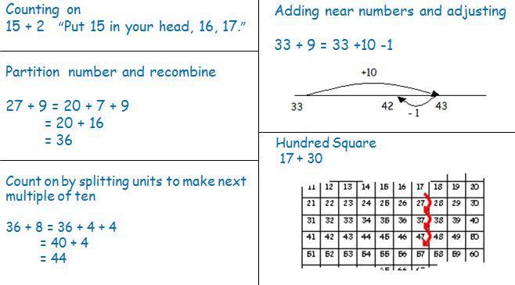  - two two-digit numbers  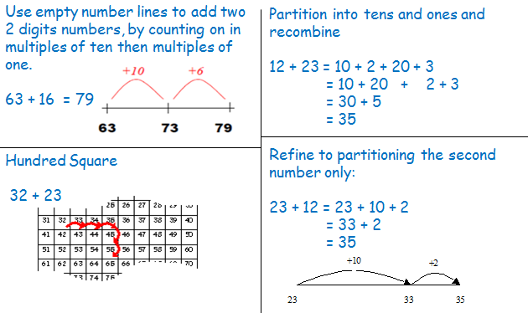  - adding three one-digit numbers  Use knowledge of adding, for example number bonds first or largest numbers first.  3 + 9 + 7 = (3 +7) + 9  = 10 + 9  = 19 | subtract numbers using concrete objects, pictorial representations, and mentally, including:  - a two-digit number and ones or tens  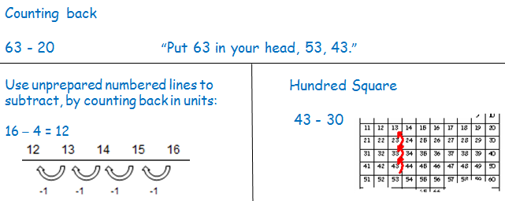  - two two-digit numbers  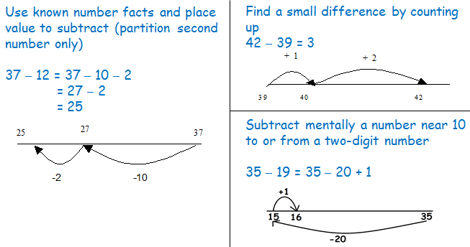 | connect the 10 multiplication table to place value, and the 5 multiplication table to the divisions on the clock face  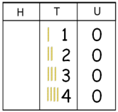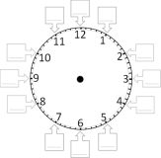 |  | connect the 10 multiplication table to place value, and the 5 multiplication table to the divisions on the clock face
 |  | relate multiplication to arrays and to repeated addition using a range of materials and contexts  Practically combine groups of objects (2s, 5s and 10s) and verbalise (then record) what has been found out: There are 3 plates. Each plate has 2 star biscuits on. How many biscuits are there? 2 add 2 add 2 equals 6    Mum washed 5 pairs of socks, how many socks did she get out of the washing machine? 2 + 2 + 2 + 2 + 2 = 10  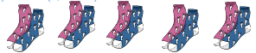  Use arrays for repeated addition and relate this to the x calculation:  (Use counters or objects as well as visual representations to support understanding)  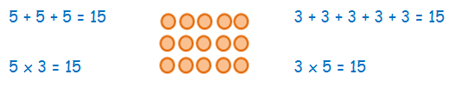  Use a number line for repeated addition:  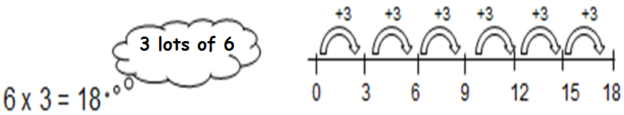 | relate division to grouping and sharing discrete and continuous quantities, to arrays and to repeated subtraction using a range of materials and contexts  Initially, pupils to practically ‘share’ and ‘group’ using practical equipment and pictorial representation. Move on to using arrays to identify groups, use physical counters before pictorial representations:  How many groups of 3 are in 15?  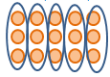  Grouping using a number line:  There are 30 children in the class, how many groups of 5 can we get into?  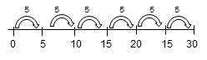  Use counters to support pupils understanding:  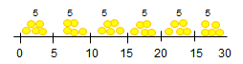
record addition and subtraction in columns  Use partitioned column method.  Solve calculations that do not cross the tens boundary, until they are secure with the method. Then solve calculations that do cross the tens boundary. Use base 10 (diennes) to support the understanding of ‘carrying’ and the value of ‘digits’.  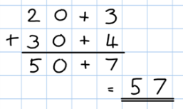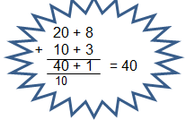  28 + 13  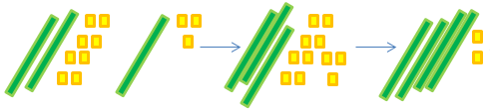 | record subtraction in columns  Introduce partitioned column method where no exchanging is required:  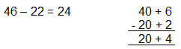  use base 10 (diennes) to support understanding  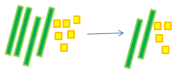 | calculate mathematical statements for multiplication within the multiplication tables and write them using the multiplication (×) and equals (=) signs  3 x 4 = 12  Repetition of sentence with different vocabulary:  “3 times 4 equals 12”  “3 lots of 4 are 12”  “3 multiplied by 4 equals 12”  “The product of 3 and 4 is 12” | calculate mathematical statements for division within the multiplication tables and write them using the division (÷) and equals (=) signs  12 ÷ 4 = 3  Repetition of sentence with different vocabulary:  “12 divided by 4 equals 3”  “12 shared by 4 is 3”  “12 grouped into 4s is 3”
solve problems with addition:  - using concrete objects and pictorial representations, including those involving numbers, quantities and measures  - applying increasing knowledge of mental and written methods  Use all the models and images mentioned above. Discuss which is most effective and why.  Singapore Bar Method | solve problems with subtraction:  - using concrete objects and pictorial representations, including those involving numbers, quantities and measures  applying increasing knowledge of mental and written methods  Use all the models and images mentioned above. Discuss which is most effective and why.  Singapore Bar Method | solve problems involving multiplication, using materials, arrays, repeated addition, mental methods, and multiplication facts, including problems in contexts  Use all the models and images mentioned above. Discuss which is most effective and why.  Singapore Bar Method | solve problems involving division, using materials, arrays, repeated addition, mental methods, and division facts, including problems in contexts  Use all the models and images mentioned above. Discuss which is most effective and why.  Singapore Bar Method
recognise and use the inverse relationship between addition and subtraction and use this to solve missing number problems  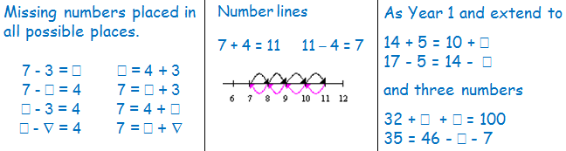 |  | recognise and use the inverse relationship between multiplication and division and use this to solve missing number problems  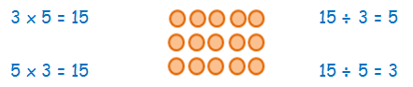
show that addition of two numbers can be done in any order (commutative)  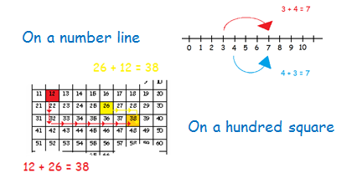 | show that subtraction of two numbers cannot be done in any order  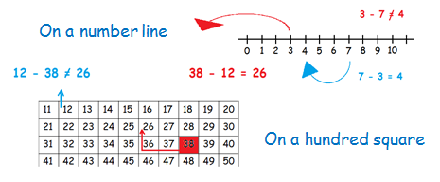 | show that multiplication of two numbers can be done in any order (commutative)  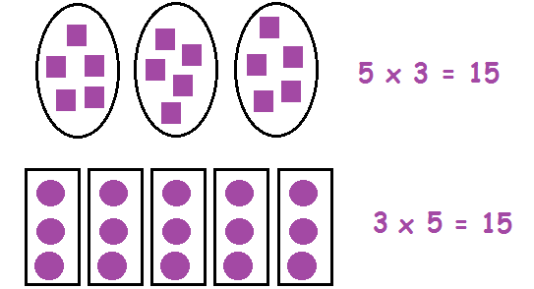 | show that division of one number by another cannot be done in any order  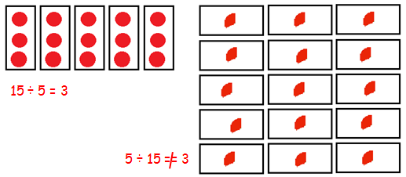
check their calculations, including adding numbers in a different order to check addition (for example, 5 + 2 + 1 = 1 + 5 + 2 = 1 + 2 + 5) - establishing commutativity and associativity of addition  See models and images above. | check their calculations, including by adding to check subtraction  See models and images above.
recognise and use the inverse relationship between addition and subtraction and use this to check calculations  See models and images above. | recognise and use the inverse relationship between addition and subtraction and use this to check calculations  See models and images above. | use commutativity and inverse relations to develop multiplicative reasoning (for example, 4 × 5 = 20 and 20 ÷ 5 = 4)  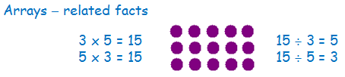
extend their understanding of the language of addition to include sum  +, add, more, plus, make, sum, total, altogether, score, double, near double, one more, two more… ten more, How many more to make…? How many more is… than…? How much more is…? Repetition of facts with different vocabulary:  “What is 2 add 5?” “What is 2 more than 5?”  “What is 2 plus 5?” What is the total of 2 and 5?” etc  = equals, sign, is the same as | extend their understanding of the language of subtraction to include difference  - subtract, subtraction, take (away), minus, leave, how many are left/left over? one less, two less… ten less… one hundred less, how many fewer is… than…? how much less is…? difference between, half, halve, tens boundary  13 + 5 = 8 Repetition of sentence with different vocabulary:  “13 subtract 5 equals 8” “5 less than 13 is 8  “13 take away 5 equals 8” “The difference between 13 and 5 is 8” etc  = equals, sign, is the same as | use a variety of language to describe multiplication  count on (from, to), count back (from, to), count in ones, twos, threes, fours, fives… count in tens, lots of, groups of, x, times, multiply, multiplied by, multiple of, once, twice, three times… ten times… times as (big, long, wide… and so on), repeated addition, array, row, column, double, halve  = equals, sign, is the same as | use a variety of language to describe division  Array, row, column, halve, share, share equally, one each, two each, three each… group in pairs, threes… tens, equal groups of, ÷, divide, divided by, divided into, left, left over  = equals, sign, is the same as

